**My Puzzler Project**

As a part of my Udacity VR nanodegree projects, I created a VR experience called “Puzzler”. Puzzler is a puzzle game surrounded by the theme of magical, mysterious, and dark dungeon. Puzzler insists the players to figure out the secret hidden behind shadowy orbs.

**Unique Considerations**

There are too many that comes to mind, but one of the most important considerations were to make the VR experience easy to play while maintaining stable framerate, trying to keep the users away from motion sickness. Also, the goal was to do all that in one simple package.

**Puzzler**

The project turned out to be good with the help of constant user testing after each major step and following it up with notable improvements. It also helped testers get access to early versions and experience the “Puzzler” building process.

**Video Preview:**



**Screenshot Preview:**

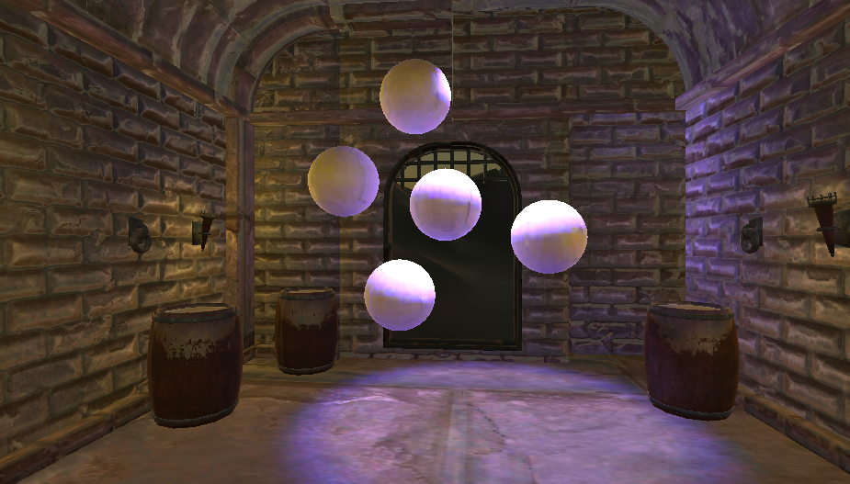

**The Process**

The Puzzler is a VR Experience created while keeping in mind that it is for new users looking for a challenge while doing experiencing something new.

**Persona**

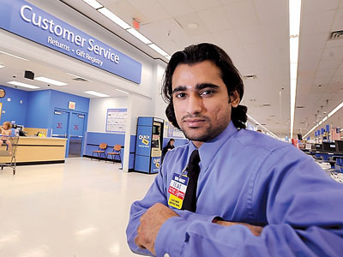

For this project, I created a persona called Yoshi, he is 21. Yoshi works as customer service manager for a retail store part time while taking college classes full time. Yoshi is a technology enthusiast and likes to try everything new and interesting to him in the technology world. Yoshi likes to play games anytime he gets free time on weekdays and on weekends.

**Sketches**

Here are some of the early work sketches that led to final design:

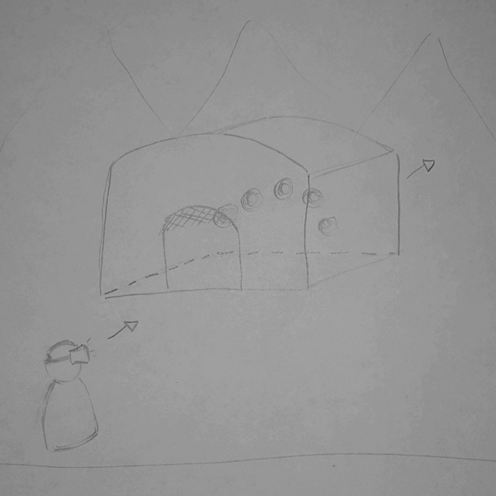

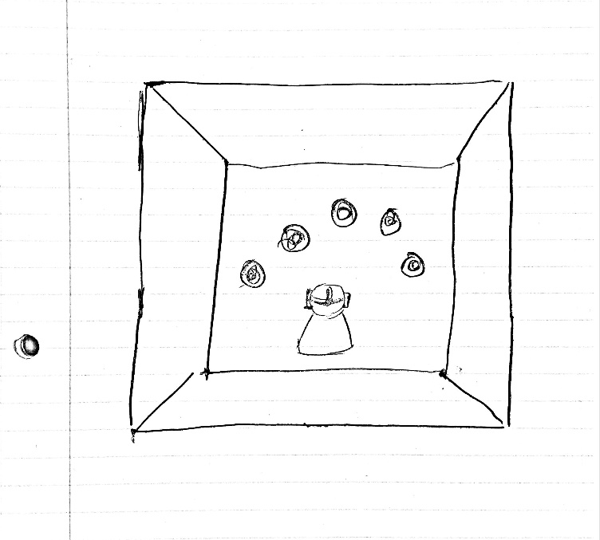

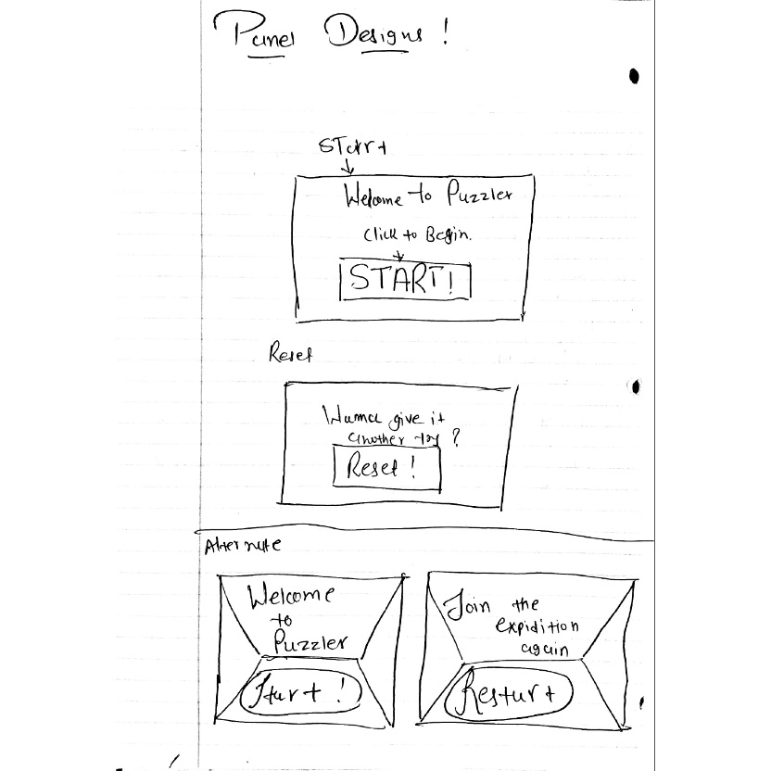

**User Testing**

1. **User Testing the Basic Environment and the Mood:**

At the time of the user test, the environment of the VR experience felt mysterious, dark and magical to the user. The user felt like he was as tall as he is in real life, in VR experience. Also, the player experienced some weird effect on the floor textures which were fixed in the next revision.

1. **User Testing the User-Interface:**

At the time of the user testing, the user saw a large white board sized panel that welcomed him and asked him if he wanted to start the user experience. The user suggested that the panel’s size can be increased “a little bit more”, which was done in the next revision.

The user had the clear idea that the UI panel was for starting the experience. When user pressed the “Start” button on start UI panel, he discovered a new UI panel for resetting the VR experience.

1. **User Testing the Movement System:**

While testing the movement system, the user noticed that the frame rate of the experience was slow and may affect the experienced. He also felt the movement being a bit too slow after pressing the start button.

**Breakdown of the final piece**

1. The feedback of user testing the environment helped me fix the textures of the floor as well as discover some other unfinished textures, which were fixed immediately after the discovery. Dark skybox was added to make the experience more immersive, while looking around when starting the experience and looking through the doors while solving the puzzle.

1. The user found the panels to be tad bit small, so following the suggestion, the size of the panel was increased and tested again with multiple users to find the optimal size. The design of the panel was kept same as it was at the time of testing.

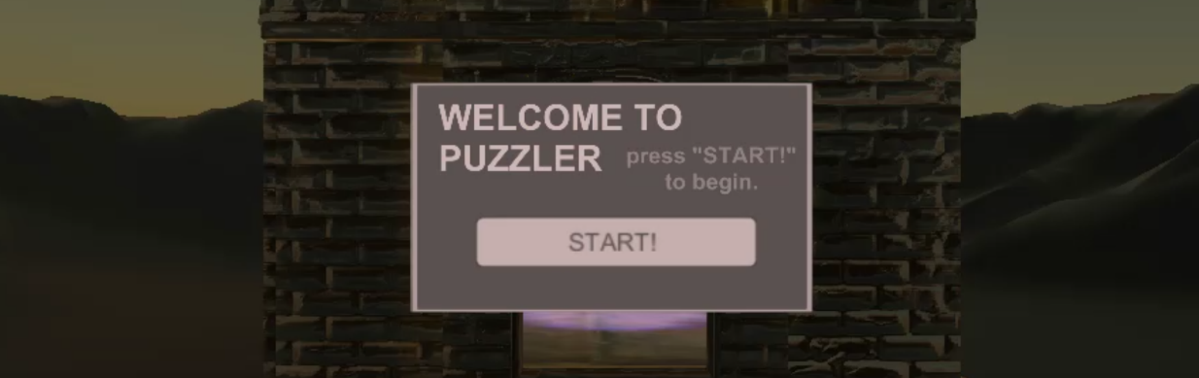

1. Following the suggestions of the user, the framerate vastly improved by making appropriate changes to quality settings. The movement speed was increased to make experience feel more natural and smooth.

**Conclusion**

In summary, the VR experience turned out to be great. It captured the feeling of mysterious and dark dungeon, kept a smooth and stable frame rate and was nice to look at through a piece of cardboard and a couple pieces of glass.